**Importance of Git and GitHub**

Pathway: <https://degreed.com/pathway/08qdegrlpr/pathway?path=git>  
  
1) [Blended Learning Program Git & GitHub Mentoring Session 1 - 9th August 2023 - 02_00 PM TO 05_00 PM - 23071928RCTechNext-20230809_140636-Meeting Recording.mp4](https://capgemini-my.sharepoint.com/:v:/p/alka_jhanwar/EV8w7zaCpdNPkt2IMSicUioB0L9kNomM_yeXEbB0ZW5E8Q?isSPOFile=1)

2) [Blended Learning Program Git & GitHub Mentoring Session 2 - 16th August 2023 - 02_00 PM TO 05_00 PM - 23071928RCTechNext-20230816_140508-Meeting Recording.mp4](https://capgemini-my.sharepoint.com/:v:/p/alka_jhanwar/ERhLJ-Fmuw5JjVVoWcN_064BtLAPMuIiIBCc0Yz6o4KgUg?e=masJGb)

3) [Blended Learning Program Git & GitHub Mentoring Session 3 - 21st August 2023 - 02_00 PM TO 05_00 PM - 23071928RCTechNext-20230821_140543-Meeting Recording.mp4](https://capgemini-my.sharepoint.com/:v:/p/alka_jhanwar/EZ4yT2hJvDpGm2mKWLIUz7gBjZ2UZJi4DKuJWXluYvhPQg)

1. **What is Git? and why we use git**

* Git is a popular source controller
* Distributed system. Free and open source
* Git is a repository, where we commit our objects
* This is for control to track and maintain the developer changes
* So, Git is version control system. Meaning of version control is managing of our source codes.
* It can help us for multiple users can work together and we can handle the larger projects efficiently using git and GitHub.

1. **Difference of git and GitHub?**

* **GIT** - Git is for managing our repository in locally.
* **GitHub** - We using GitHub create a centralized repository or remote repository.

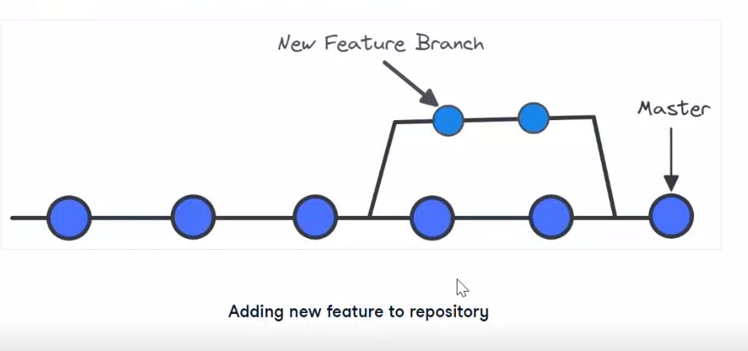  
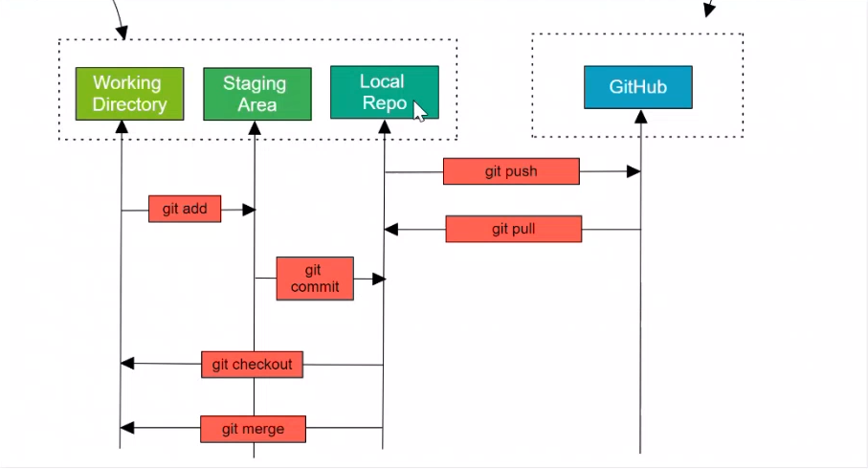

1. **some Linux commands are:**

* Check the present working directory **pwd**

use (pwd) command **Ex**: it shows /c/Users/varunkm

* Use (ls) command list all our data
* (git --version) it will display git version
* Configure our username and email

git config --global user.name "varun kumar"

git config --global user.email [varunkumarkm44@gmail.com](mailto:varunkumarkm44@gmail.com)

* **git init**: it is initializing a git repository
* **git status:** It shows a status
* **git add .** or **git add filename**
* **git commit -m "initial commit"** adds the commit message

We want to check which user is configure and which email and username used

* git config –list

We want to check the username

* git config --global user.name

Same way we want to check email

* git config --global user. email

Once we add, we need to remove the staging

* git restore --staged file name

We want to open the folder in vscode

* code .

How to add a new commit message

* git commit --named -m ""

We can check the logs of our commit

* git log

We want to check the online log

* git log --online

For every commit one id is created, committing a modified file (This command is only work for when we modified the file) it’s adding all the files which we modified

* git commit -a -m "file name"

It's showing a difference of modified file and committed file, showing what new things are added

* git diff

After **git add .** use this command, the check git diff it’s not showing anything after we check using this command (git diff --staged)

Sometimes we working we don't want to add our local repository

we create one file (.**gitignore**) on our IDE after we specify a file name which we do not add to stage, then that file is not showing to commit we can write any number of log file on **.gitignore** file we use on more command **\*.log** when we not adding an any specified name we use /filename

How we delete our local repository

* rm -rf .git

Remove file for the IDE

* rm filename

We want to remove the committed file

* git rm file name

We want to rename the file name

* git mv initialName newName

**Branches:**

1. Why we created the branches?

* Because when we are working on the project multiple people can working, all people are not working on the master branch.
* what we can do, we create a new branch form the existing version then the person can work on that branch and then if the task is completed it can be merge with the master branch.
* For each people can working different branches, and whenever the task is completed then finally merge with the master branch.

We want check how many branches are there

* git branch

How to create a branch

* git branch branchname

**Ex**: git branch development

How we switch to the development branch

* git checkout development
* git checkout command is used to switch the one branch to another

I wanted to merge with master branch to our development branch

* git merge development (But current branch is master)

Merge all the development files, we come out to initial page use escape and: wq

Another way to create a branch name

* git checkout -b testing
* Instead of we are using two commands here we use only one command

We need to check how many branches are merged on master branch

* git branch --merged

We need to check not merged branches

* git branch --no-merged